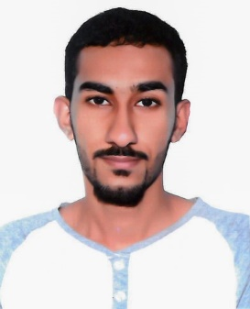

Hussain Abdulla Maki

Bu quwa, Kingdom of Bahrain

Mobile: 39440106

HussainAbdulla2999@gmail.com

Nationality: Bahraini

DOB: 01/05/1998

Marital Status: Single

**SKILLS**

• Router setup and configuration, Microsoft Office (Word –Power Point – Excel), Setup and install SW, Wire Fittings, Install, Cut, Connect, Change Lights.

**.** Good command of English and Arabic.

**.** Good skills in sales.

**.** Driving license and my own transportation.

**EDUCATION**

**Present** **AMA International University** Manama, Bahrain

Bachelor of Mechatronics Engineering student

**2013 - 2016**  **Ahmed Al-Omran Secondary school** Manama, Bahrain

High School, Chemistry and Biology

**EXPERIENCE**

**2014** Trainee at Bahrain Post- Bahrain Mall Manama, Bahrain

**2018 volunteer at DreamLandExpo Event** Bahrain Circuit

**Responsibility:**

* Electrical Workers (Install, Cut, Connect & power LED Strip Lighting, Change Led lights and light bulb )

**JUNE 2017- Sep 2017 Carriage Bahrain**  Manama, Bahrain

Driver

**Jan 2019 - Present The Yard Construction** Manama, Bahrain

Driver

**HOBBIES**

Foot boll – Swimming - Fishing